THE AFRICAN WORLD HERITAGE FUND (AWHF) AT THE 42nd WORLD HERITAGE COMMITTEE MEETING IN MANAMA, BAHRAIN 2018
TWO AFRICAN SITES INSCRIBED ON THE WORLD HERITAGE LIST – KENYA & SOUTH AFRICA
1). THIMLICH OHINGA WORLD HERITAGE SITE - KENYA
The Thimlich Ohinga (Kenya), is the largest and best preserved dry-stone wall settlement, typical of Kenya’s Lake Victoria region. The settlement, situated north-west of Migori town, is thought to have been built in the 16th Century and appears to have served as a fort for communities and livestock.
UNESCO called it “an exceptional example of the tradition of the first pastoral communities in the Lake Victoria Basin”.

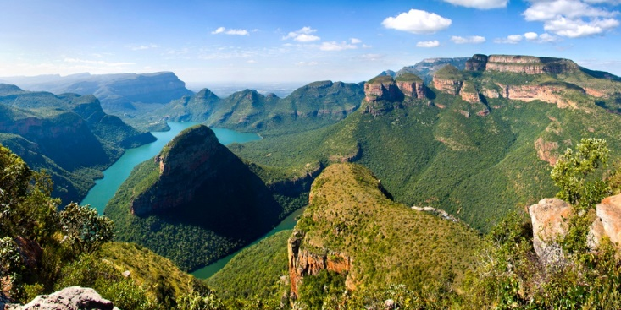

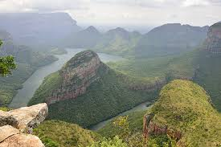
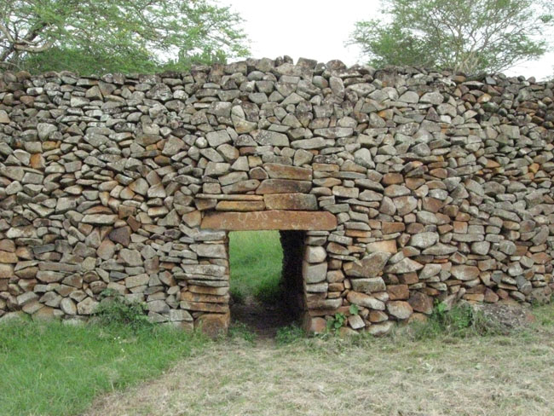
Barberton Makhonjwa Mountains, South Africa ©AIA

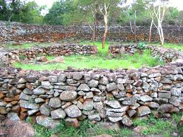
Thimlich Ohinga, Kenya ©AIA

2). BARBERTON MAKHONJWA MOUNTAINS – SOUTH AFRICA
The Makhonjwa Mountains (South Africa), also known as the Barberton Mountain Land, is a range of small mountains and hills that covers an area of 120 by 60 kilometres (75 by 37 mi), about 80% in Mpumalanga, a province of South Africa, and the remainder in neighbouring Swaziland. Along with its exceptional geology, the area is rich in wild plants, animals and beautiful scenery.
The Site is truly unique, containing the oldest and best preserved sequence of volcanic and sedimentary rocks on earth.

The result of the two inscriptions is significant and constitutes a commendable way forward for World Heritage implementation in the African region. This inscription is achieved through efforts by many stakeholders working closely with the African World Heritage Fund including the World Heritage Committee members (Angola, Burkina Faso, Tanzania, Tunisia and Zimbabwe), the World Heritage Centre and Advisory Bodies as well as the Centre for Heritage Development in Africa (CHDA) and the School of African Heritage (EPA).
AWHF congratulates and commends the State Party of Kenya and other international countries for this successful achievement.

- AWHF SIDE EVENT ON “WORLD HERITAGE AND SUSTAINABLE DEVELOPMENT IN AFRICA”
At this year’s 42nd World heritage Committee Session gathering of global scope, the African World Heritage Fund (AWHF) together with the Africa Unit at the UNESCO World Heritage Centre (WHC) partnered with ICOMOS to organize a Side Event themed “World heritage and Sustainable Development in Africa”, aiming at raising awareness on specific issues related to the implementation of the World Heritage Convention in Africa.
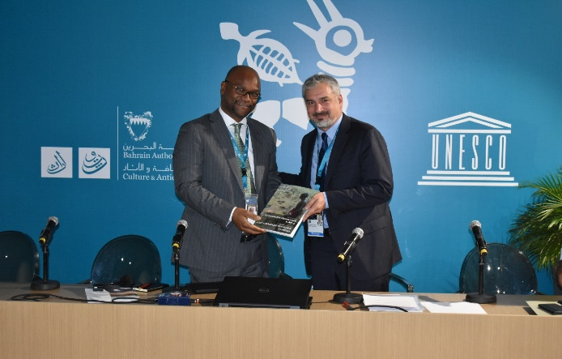
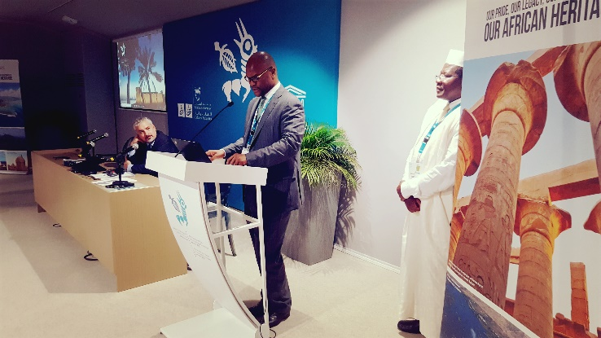
The event gathered more than 100 guests and delegates. The main speakers included UNESCO Assistant Director General for Culture, Mr. Ernesto Renato Ottone Ramirez, Minister of Arts and Culture, South Africa, Honourable Nathi Mthethwa, Director General for ICCROM, Dr. Webber Ndoro, IUCN Representative, Mr. Youssouph DIEDHIOU and Prof Christina Cameron (Patron of AWHF). Other Ministers present were: Prof Narcisse Mouelle Kombi, Minister of Arts and Culture, Cameroon and Honourable Dr. Jules Doret Ndongo, Minister of Forestry and Wildlife, Cameroon.

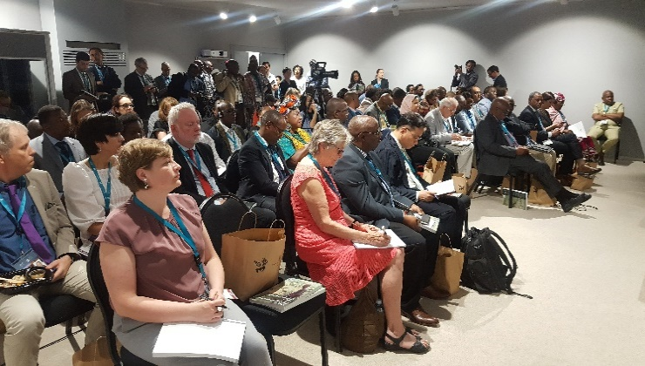
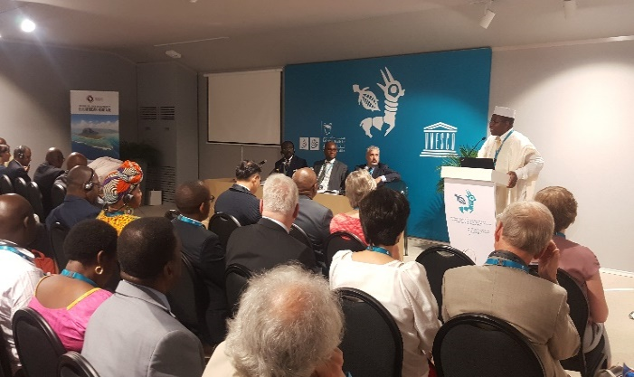

Side Event on “World Heritage and Sustainable Development” in progress ©AWHF
- MINISTERIAL ROUNDTABLE MEETING ON “WORLD HERITAGE ISSUES IN AFRICA”
A ministerial roundtable meeting on “World heritage issues in Africa” was convened on 28th June by Honourable Nathi Mthethwa, Minister of Arts and Culture, South Africa and gathered Prof Narcisse Mouelle Kombi, Minister of Arts and Culture, Cameroon and Honourable Dr. Jules Doret Ndongo, Minister of Forestry and Wildlife, Cameroon and various other African delegation leaders, Ambassadors and partners. The meeting was aimed at providing a platform for discussion on few heritage-related issues on the African continent. As Minister hosting AWHF, Honourable Nathi Mthethwa thought that it was right to also use the World heritage Meeting platform to further engage with African leaders in a constructive way.
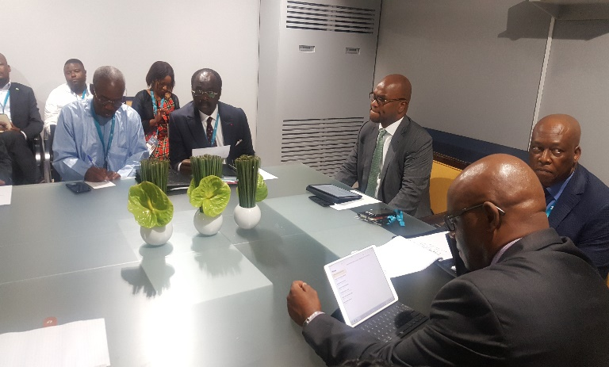
The meeting focused on a number of topics including:
a). The Heritage Sites associated with memories of recent conflicts (independence and liberation heritages, genocide sites, iconic places during the 2nd World War, slavery routes etc.) to be nominated as World Heritage.
b). Issues about World Heritage and Sustainable Development in Africa.
c). The support to the African World Heritage Fund (AWHF).

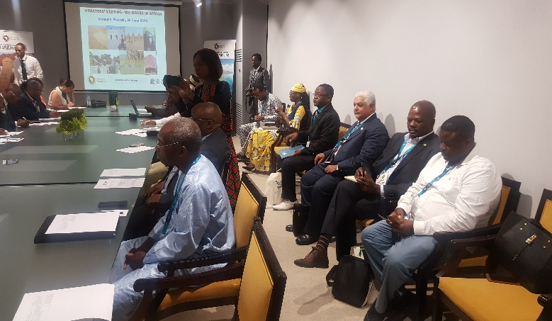

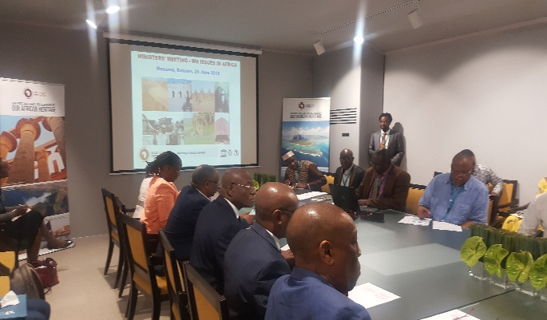

Ministerial Roundtable Meeting on “World Heritage Issues in Africa” in progress ©AWHF

- CAMEROON EXHIBITION ON “CAMEROON, HERITAGE OF ATTRACTIVENESS”
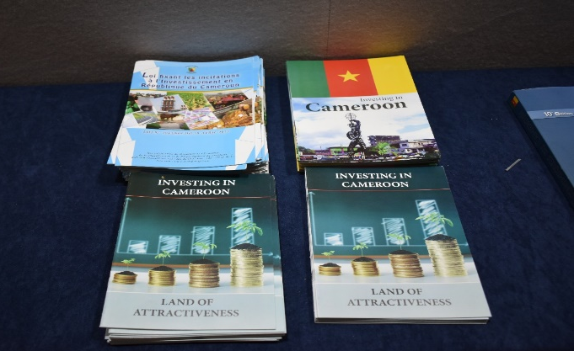
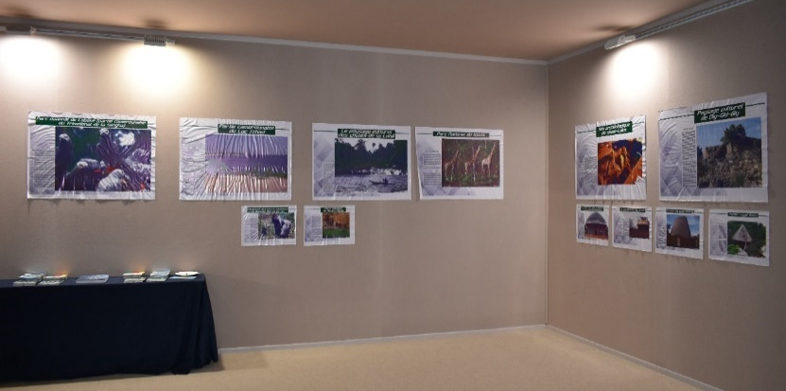
Cameroon also utilized the platform and held a Side Event which included a display of an exhibition on “Richness of the Cameroon heritage” by showcasing Cameroon as a land of attractiveness with various opportunities for investing.

- MEETINGS WITH PARTNERS
Furthermore, AWHF held meetings with several delegations on issues related to partnerships and to further strengthen relations and growth opportunities for the Fund. The delegations engaged included ICOMS, the Minister of Culture of Cameroon, delegation of Saudi Arabia, Botswana, Arab Centre and Benin. Daily meetings were also held with various African delegations.
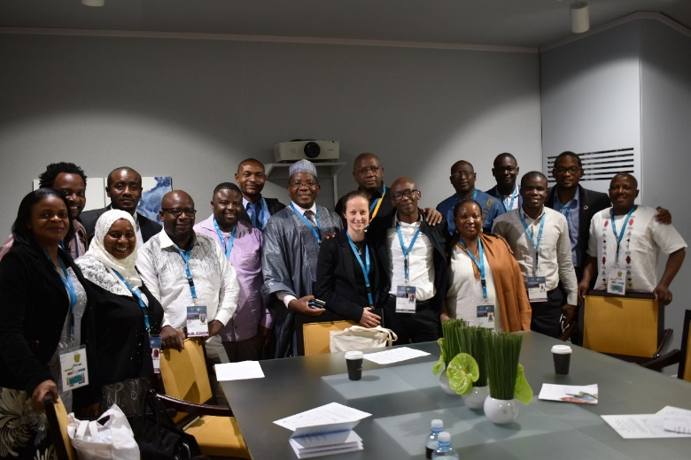
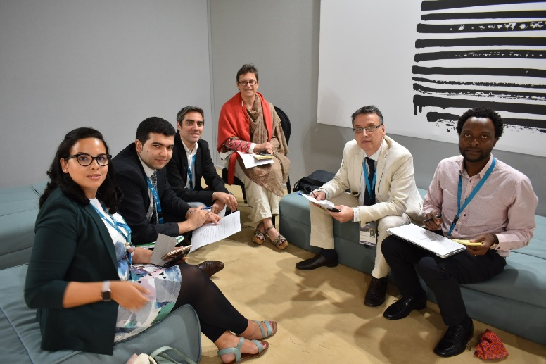

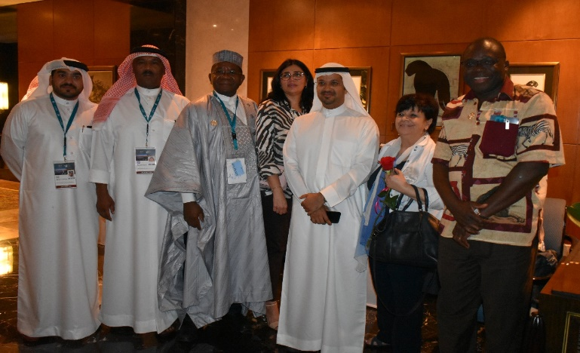
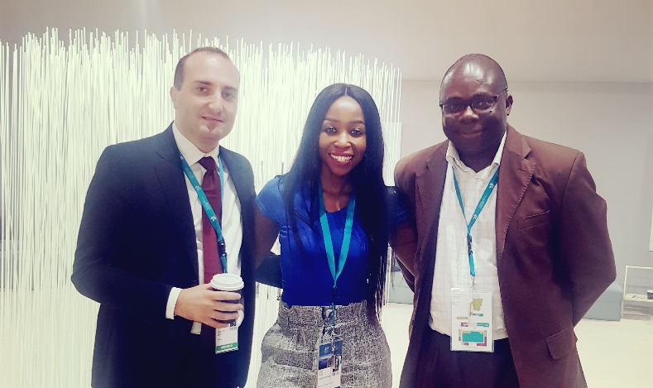
Meeting with C2C Representatives ©AWHF Meeting with African Site Managers ©AWHF

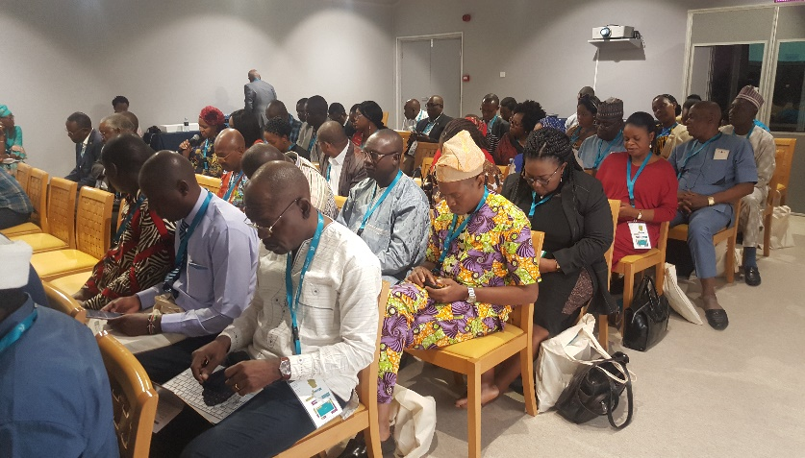
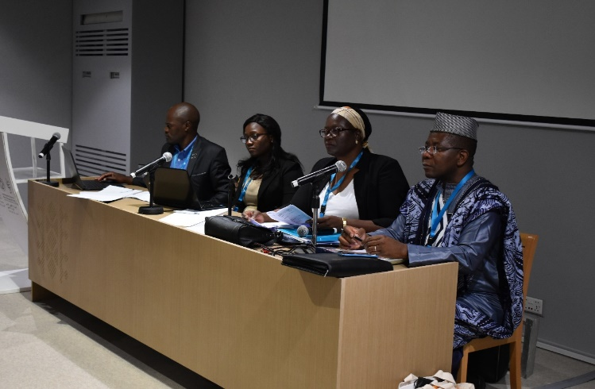
Deputy Minister of Culture, Montenegro ©AWHF Centre for Arab Region Delegation ©AWHF

Daily African Delegation Meeting ©AWHF Daily African Delegation Meetings ©AWHF

